Godly Play®

Lent at Home

*I wonder what Lent makes when you live it all the way through?*

*A resource developed by the Rev. Dr. Cheryl V. Minor,*

*Director of the Center for the Theology of Childhood for the Godly Play Foundation*

*with Godly Play Resources*



Lent is a season when many people look for ways to more intentionally nurture their relationship with God. Jesus Christ’s life, ministry, and death are remembered during this season. It’s also a time to think about how God is with us all the time. You may do this through prayer, reading the Bible, helping others, or some other meaningful way to connect you to God. We invite you and your family to take some time each week to “mark” this important season using these Godly Play materials.

Contents of your Lent at Home Bag:

* Purple underlay (felt)
* Candle
* Burlap Bunting
* Mystery of Easter (Cross Puzzle) & Purple Bag
* Faces of Easter Coloring Sheets
* Easter Egg Template
* Easter Egg & Colored Pencils
* Parent Pages for all the stories

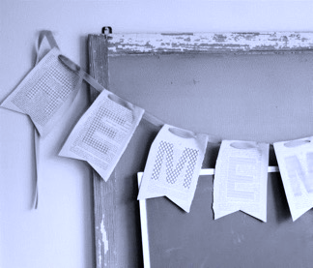**SHROVE TUESDAY ~ Alleluia/Remember Banner**

Some churches have the custom of not speaking or singing the word *Alleluia* during Lent. *Alleluias* are joyful proclamations, which we put away during the more contemplative season of Lent. Putting away the *Alleluias* for Lent is like putting away a favorite toy for a while – to appreciate it better later. Churches often take banners down or eliminate flowers in the sanctuary. The Sunday readings and prayers take on a more penitential tone.

On Shrove Tuesday (the Tuesday before Ash Wednesday), use the burlap bunting included in your bag to make an *Alleluia* banner by writing one letter on each section. A wide permanent marker should work well. You could also do bubble letters and have the children fill them in with color or drawings. Afterwards hide the *Alleluia* away somewhere in your house and make plans to pull it out on Easter morning and display it.

Alternatively you can write the word *Remember* on the reverse and hang it over your worship table or in your dining room. Then on Easter morning you can turn it over to reveal the *Alleluia!*

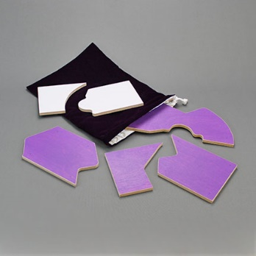 **ASH WEDNESDAY ~ The Mystery of Easter**

On Ash Wednesday create a Holy Table or shelf in your home where you and your family can gather each week. It could just be your dining room or kitchen table. In your bag you will find a candle, and a purple underlay (felt). Place these items in your chosen spot to help create a sacred space in your home where you can gather each week to explore the Godly Play materials in your bag.

In your bag you will also find paper (white on one said, purple on the other) with puzzle pieces drawn on it. Cut out the puzzle and place it in the small purple bag. Then gather your family, light the candle, and use the puzzle in the bag to explore the presentation called, “the Mystery of Easter.” Use the Parent Page (included in this bag) as your guide. You can also view a demonstration video of the presentation here: <https://youtu.be/ivkLTqkiWjc>

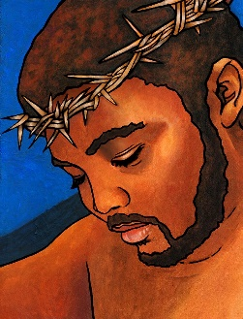**SUNDAYS IN LENT ~ The Faces of Easter**

Included in your bag are the images needed to share this series of stories throughout the season of Lent. They are in black and white so we suggest you and your family spend time each week coloring them before sharing the story. Use the Parent Pages (included in the bag) to tell each part of the story. For more help visit [www.storiesofgodathome.com](http://www.storiesofgodathome.com) where you will find a demonstration video.

Here is a suggested outline for your weekly family time:

1. Color the story image for the week.
2. Light the candle.
3. Lay out the images from the previous weeks to remember the stories you’ve already done.
4. Lay out the image for the week and use the Parent Page to tell the story.
5. Spend some time discussing the wondering prompts.
6. Put the materials back in the bag, blow out the candle and say, “Our family is part of this story. Thanks be to God. Amen.”

When we tell this series of stories in our Godly Play room we invite the children to look around the room to see if there is something they can bring to the story to help us tell the story better. You can try this at home too. Use this time to weave your family stories with the story of Jesus. Below you will find some suggested wondering questions to help get you started.

**A word about wondering**: A question entails an answer by the way it is posed, but a wondering is something to which you do not know the answer. Wonderings invite those listening to join together to honor each unique, personal response to God’s mystery. In a classical Godly Play room the storyteller does not generally “wonder” out loud, but in this setting it is appropriate. It could, for example, be a way for you to share a significant or well-loved family story, to share how you were able to get through a difficult time, or to talk about where you have experienced the presence of God.

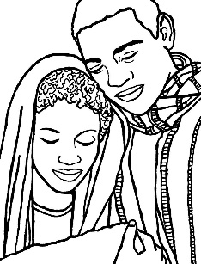The First Sunday in Lent: The Face of Easter One

Jesus’ Birth and Growth

* *I wonder if anyone in this family was ever born? I wonder what that amazing day was like?* (Take this opportunity to tell birth stories as a family.)
* *I wonder if there is anything in our house that we could bring to this story to help us tell it better*? (Bring baby photos, perhaps figures from your nativity set, etc.)

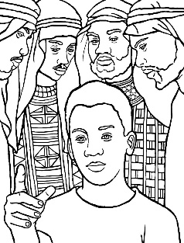The Second Sunday in Lent: The Face of Easter Two

Jesus is Lost and Found

* *I wonder if anyone in this family has ever been lost?* (Share stories of times when you were lost, or when you thought you were lost.)
* *I wonder if anyone in this family has ever been found?* (Share stories about how you were found or people who helped you. Include stories, when appropriate, about how you found your partner, your calling, and more.)
* *I wonder if there is anything in our house that we could bring to this story to help us tell it better*?

The Third Sunday in Lent: The Face of Easter Three

Jesus’ Baptism and Blessing by God

* *I wonder if anyone in our family has been baptized?*

(Tell baptism stories. If you can, pull out the clothes your child wore, and talk about who was there that day, what you did to celebrate, etc.)

* *I wonder if there is anything in our house that we could bring to this story to help us tell it better*?

The Fourth Sunday in Lent: The Face of Easter Four

Jesus’ Desert and Discovery Experience

* *I wonder if anyone in our family has ever wondered about who they are or what their work is going to be?* (Tell stories about how you discovered your vocation, or maybe how you decided you wanted to be a parent. How did you know? Invite the children to dream about what their work might be now – being a friend, a sibling, an artist, a musician or what it might be when they grow up.)
* *I wonder if there is anything in our house that we could bring to this story to help us tell it better?* (If your work has special tools you could bring them to the story, or something that represents your work. What will the children bring?)

The Fifth Sunday in Lent: The Face of Easter Five

Jesus as Healer and Parable Maker

* *I wonder if anyone in our family ever came close to God? I wonder if there are times when you felt like God was far away?* (Share times in your own life when you felt close to God – at Church, in nature, when you were holding your child, etc. Also share those times when you did not feel close to God. Invite your child to do the same.)
* *I wonder if there is anything in our house that we could bring to this story to help us tell it better?* (Share photos of your favorite place to pray or feel close to God – your favorite beach, the church where you worship, etc.)

Palm Sunday: the Face of Easter Six

Jesus offers the Bread and Wine

* *I wonder if anyone in this family ever discovered something new when sharing the Holy Bread and the Holy Wine?* (Share stories about what feels most important to you when sharing communion. What part do you like best? What part seems most important? I wonder what other kinds of holy meals you share as a family? Special food? Special traditions at Christmas or Easter? What might make them holy or sacred?)
* *I wonder if there is anything in our house that we could bring to this story to help us tell it better?*

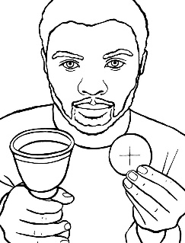

Easter Day: The Face of Easter Seven

The one who was Easter and still is.

**Special Note**: These last two images are meant to be glued, back to back, so that the Face of Good Friday and the Face of Easter are always together. You cannot take them apart! After coloring the images, glue them together before sharing the story from the Parent Page.

* *I wonder if anyone in this family has ever entered the Mystery of Easter? I wonder what you found?* (Share stories about what you love about Holy Week and Easter. What is your favorite part? What part is most important? I wonder why? Invite your children to do the same.)
* *I wonder if there is anything in our house that we could bring to this story to help us tell it better?*
* *Close this special time together by getting out* *out the Alleluia Banner you made at the beginning of Lent and display it somewhere in your home! It is also a great time to shout or sing, “Alleluia!” and ring bells.*

*Make a joyful noise! Jesus is Risen! He is Risen indeed!*

**CELEBRATING EASTER**

**The Legend of the Easter Egg**

Included in your bag is a wooden egg and colored pencils to use to decorate the egg. You will also find a template with suggested design elements often used on Ukrainian Easter Eggs. Your children can design their own egg and/or paint Easter eggs in the way your family usually does, as you share “The Legend of the Easter Egg” (see the parent page for this story included in your bag). This story is, as the name implies, is a legend, but it has its starting point something we do read about in the story of the Passion – the encounter that Jesus has on the way to the cross with a man named Simon of Cyrene who was “coming in from the country” on the day of the crucifixion (Matthew 27:32, Mark 15:21, Luke 23:26). It is a wonderful way to reclaim the Easter eggs associated with the Easter bunny this time of year, with the story of Jesus’ death and resurrection.

**Other activities you could do to help keep Lent at Home**

* Give up something as a family. Jesus fasted for 40 days. That is a very long time! It would be meaningful to teach your children about fasting by giving up something for the entire Lenten season or on Fridays during Lent. The key, of course, is that it has to be something you enjoy and want to do/eat/have. If you hate brussels sprouts and decide to give them up during Lent, you may need to come up with something different.
* Make a prayer chain. Write a person or situation on each of 40 strips of paper. Assemble them into a paper chain. Remove one link per day, and pray for that thing with your children.
* Reach out in love to your friends or neighbors a few times during Lent.
  + Make dinner for a friend
  + Bring flowers to a friend.
  + Make an appreciation card for a teacher.
  + Roll the trash cans in for a neighbor after trash pick-up.
  + Organize some face-time with a grandparent or friend who lives far away.
* Get outside and go on a “wonder walk” around your neighborhood or in a local park. As a family look for things that cause you to “wonder” – an interesting tree, an animal, the clouds, and more! I wonder what these things say to us about God, who created everything!
* Make twig crosses. Gather twigs 8 to 12 inches long. Form crosses with two twigs each. Wind yarn around where the twigs intersect until the cross is very stable. Black or purple yarn would be very appropriate.
* Bake pretzels. Pretzels were first baked during Lent because they can be made with only water, flour, and salt. The shape came from a posture of prayer, with arms crossed and hands on opposite shoulders. A monk made dough into this criss-crossed shape, and the pretzel was born!

This page blank for you to fill in with announcements

about special events in your parish.

When you print this, we recommend using the booklet setting on your printer and 8.5x14 paper. You can then fold it in half to create a booklet.

Of course, you can also just print it on 8.5 x 11 paper in the regular format.